TITLE OF THE SIMULATION:

Bayesian Parameter Estimation for Solar Flare Pulse using Metropolis-Hastings MCMC

NAME OF THE TEAM:

shanmukhakumar

NAMES OF TEAM MEMBERS:
1.BURUSU SHANMUKHA KUMAR
2. MOHAMMED SHAIK
3. SHARLI NELATURI

MAIN CODE:
import numpy as np
import matplotlib.pyplot as plt

# ------------------- DATA (t, s) -------------------
# Paste your first N pairs here exactly as: t s t s t s ...
raw_data = """
0 -5.23891 0.0035018 0.218728 0.0070035 -3.16885 0.0105053 6.81431
0.014007 -3.29335 0.0175088 7.26776 0.0210105 -4.47778 0.0245123 3.69452
0.028014 4.87071 0.0315158 11.1381 0.0350175 11.8183 0.0385193 -3.83294
0.042021 12.7834 0.0455228 6.90328 0.0490245 -3.17366 0.0525263 -0.682996
0.056028 4.66652 0.0595298 -0.668237 0.0630315 -1.35889 0.0665333 -1.50079
"""

nums = np.array([float(x) for x in raw_data.split()])
t = nums[0::2]
ydata = nums[1::2]

# ------------------- MODEL -------------------
def flare_model(t, A, tau, omega):
return A * np.exp(t) * (1 - np.tanh(2 * (t - tau))) * np.sin(omega * t)

def log_likelihood(theta):
A, tau, omega = theta
ymodel = flare_model(t, A, tau, omega)
sigma = 0.2 * np.abs(ydata) + 1e-8
r = (ydata - ymodel) / sigma
return -0.5 * np.sum(r * r)

def log_prior(theta):
A, tau, omega = theta
if 0 < A < 2 and 1 < tau < 10 and 1 < omega < 20:
return 0.0
return -np.inf

def log_posterior(theta):
lp = log_prior(theta)
if not np.isfinite(lp):
return -np.inf
return lp + log_likelihood(theta)

# ------------------- MCMC (Metropolis–Hastings) -------------------
def run_mh(nsteps=10000, step_sig=(0.02, 0.1, 0.3)):
A0, tau0, omega0 = 1.0, 3.0, 8.0
theta = np.array([A0, tau0, omega0], dtype=float)
lp = log_posterior(theta)

chain = np.zeros((nsteps, 3))
lps = np.zeros(nsteps)
chain[0] = theta
lps[0] = lp

step_sig = np.array(step_sig, dtype=float)

for i in range(1, nsteps):
prop = theta + step_sig * np.random.randn(3)
lp_prop = log_posterior(prop)

if np.isfinite(lp_prop):
if np.log(np.random.rand()) < (lp_prop - lp):
theta = prop
lp = lp_prop

chain[i] = theta
lps[i] = lp

return chain, lps

np.random.seed(0)
chain, lps = run_mh()

burn = len(chain) // 2
post = chain[burn:]
map_idx = np.argmax(lps[burn:]) + burn
A_map, tau_map, omega_map = chain[map_idx]

print("MAP A =", A_map)
print("MAP tau =", tau_map)
print("MAP omega =", omega_map)

# ------------------- PLOTS (DELIVERABLES) -------------------

# Trace plots
fig1, axs1 = plt.subplots(4, 1, figsize=(10, 10), sharex=True)
axs1[0].plot(chain[:, 0], lw=0.5)
axs1[0].set_ylabel("A")
axs1[0].set_title("Trace: A")

axs1[1].plot(chain[:, 1], lw=0.5)
axs1[1].set_ylabel("tau")
axs1[1].set_title("Trace: tau")

axs1[2].plot(chain[:, 2], lw=0.5)
axs1[2].set_ylabel("omega")
axs1[2].set_title("Trace: omega")

axs1[3].plot(lps, lw=0.5)
axs1[3].set_ylabel("log posterior")
axs1[3].set_xlabel("Iteration")
axs1[3].set_title("Log-posterior")

plt.tight_layout()
plt.savefig("trace_plots.png", dpi=300)

# Posterior histograms
fig2, axs2 = plt.subplots(1, 3, figsize=(12, 4))
axs2[0].hist(post[:, 0], bins=30, density=True, color="C0")
axs2[0].axvline(A_map, color="r")
axs2[0].set_xlabel("A")
axs2[0].set_title("Posterior of A")

axs2[1].hist(post[:, 1], bins=30, density=True, color="C1")
axs2[1].axvline(tau_map, color="r")
axs2[1].set_xlabel("tau")
axs2[1].set_title("Posterior of tau")

axs2[2].hist(post[:, 2], bins=30, density=True, color="C2")
axs2[2].axvline(omega_map, color="r")
axs2[2].set_xlabel("omega")
axs2[2].set_title("Posterior of omega")

plt.tight_layout()
plt.savefig("posterior_histograms.png", dpi=300)

# Data vs MAP model + residuals
y_fit = flare_model(t, A_map, tau_map, omega_map)
sigma = 0.2 * np.abs(ydata) + 1e-8
res = (ydata - y_fit) / sigma

fig3, axs3 = plt.subplots(2, 1, figsize=(10, 6), sharex=True)
axs3[0].plot(t, ydata, "k.", ms=4, label="data")
axs3[0].plot(t, y_fit, "r-", lw=1.5, label="MAP model")
axs3[0].set_ylabel("Intensity")
axs3[0].set_title("Data and MAP fit")
axs3[0].legend()

axs3[1].plot(t, res, "b.", ms=4)
axs3[1].axhline(0, color="k", lw=1)
axs3[1].set_xlabel("t")
axs3[1].set_ylabel("Residual / sigma")
axs3[1].set_title("Normalized residuals")

plt.tight_layout()
plt.savefig("fit_and_residuals.png", dpi=300)
plt.show()

DESCRIPTION OF PHYSICAL PHENOMENON:

This work presents a Bayesian statistical approach to parameter estimation for solar magnetic reconnection events observed by the Solar Dynamics Observatory (SDO). The physical system under study is a Solar Flare Pulse—a transient electromagnetic and plasma phenomenon characterized by exponential growth followed by rapid quenching as magnetic loops rupture during energy release in the solar atmosphere.
Physical Background
A solar flare is an intense, sudden, and localized variation in brightness on the Sun's surface or in its atmosphere (corona). The event exhibits a distinctive time-domain signature: the magnetic energy builds up exponentially as plasma heats during the reconnection phase, reaches a peak intensity at the quench time (τ), and then decays as the magnetic loop structure destabilizes. Superimposed on this envelope is a characteristic oscillatory component at frequency ω, representing magneto-acoustic waves trapped in the heated plasma columns.
The observed sensor intensity is corrupted by stochastic noise (measurement error and background radiation), making direct parameter extraction unreliable. A Bayesian inference framework provides a principled method to recover the true signal parameters and quantify estimation uncertainty through posterior probability distributions.

Mathematical Model and Equations Used:
Analytical Model of Solar Flare Intensity
The intensity of the solar flare as a function of time is modeled by:
$$S(t)=A⋅e^{t}⋅\{1-tanh⁡[2(t-τ)]\}⋅sin⁡(ωt)$$
where:
- A ∈ (0, 2): Amplitude scaling factor representing the intensity scale of the flare
- τ ∈ (1, 10): Quench time (event peak) marking the transition from growth to decay
- ω ∈ (1, 20): Angular frequency of the embedded oscillation in rad/s
- e^t: Exponential growth phase during magnetic energy accumulation
- {1 − tanh[2(t − τ)]}: Smooth switching function (= 1 for t ≪ τ, ≈ 0 for t ≫ τ) controlling the growth-to-decay transition
- sin(ωt): High-frequency oscillatory component (magneto-acoustic waves)
Statistical Framework
Likelihood Function
Given noisy observations D = {y₁, y₂, ..., yₙ} of the true signal at times t₁, t₂, ..., tₙ, assuming independent Gaussian measurement errors with relative standard deviation σᵢ = 0.2|yᵢ|, the log-likelihood is:
$$L=-\frac{1}{2}\sum_{i=1}^{n}{\frac{\left[y_{i}-S(t_{i};θ)]^{2}\right.}{σ_{i}^{2}}}$$
where θ = (A, τ, ω) is the parameter vector.
Prior Distribution
Uniform (flat) prior within physical bounds:
$$P(θ)=\left\{\begin{matrix}1 & \text{if }0<A<2, 1<τ<10, 1<ω<20 \\ 0 & \text{otherwise}\end{matrix}\right.$$
Posterior Distribution (Bayes' Rule)
$$P(θ∣D)∝P(D∣θ)⋅P(θ)=exp⁡(L)⋅P(θ)$$
The posterior encodes all statistical information about parameters given the data.

Approach and Simulation Methodology

Metropolis-Hastings Markov Chain Monte Carlo (MCMC)
To sample from the posterior distribution, we employ the Metropolis-Hastings algorithm, which constructs a Markov chain whose stationary distribution equals the target posterior:
Algorithm Steps
- Initialize parameters: θ₀ = (A₀, τ₀, ω₀) with initial guesses A₀ = 1.0, τ₀ = 3.0, ω₀ = 8.0
- Calculate initial posterior: log P(θ₀|D)
- Random walk proposal: For iteration i, propose θ = θᵢ₋₁ + ε* where ε ~ N(0, Σ) with step covariance matrix Σ = diag(0.02², 0.1², 0.3²)
- Metropolis acceptance ratio:
  - Compute log-posterior at proposal: log P(θ*|D)
  - Accept with probability: α = min(1, exp[log P(θ*|D) − log P(θᵢ₋₁|D)])
  - Draw u ~ Uniform(0,1); if u < α, set θᵢ = θ*, otherwise θᵢ = θᵢ₋₁
- Repeat: Execute N = 10,000 iterations
- Burn-in removal: Discard first 50% of samples (transient phase before convergence)
- Posterior statistics:
  - MAP estimate = chain value with highest log-posterior
  - Posterior distributions = histograms of post-burn-in samples

Results and Visual Outputs

he simulation produces three key deliverables:
1. Trace Plots (trace_plots.png)
- Four subplots showing iteration-wise evolution of A, τ, ω, and log-posterior.
- Vertical red dashed line indicates burn-in threshold.
- Demonstrates chain convergence (no trend after burn-in).
- Validates that the Markov chain has reached its stationary distribution.

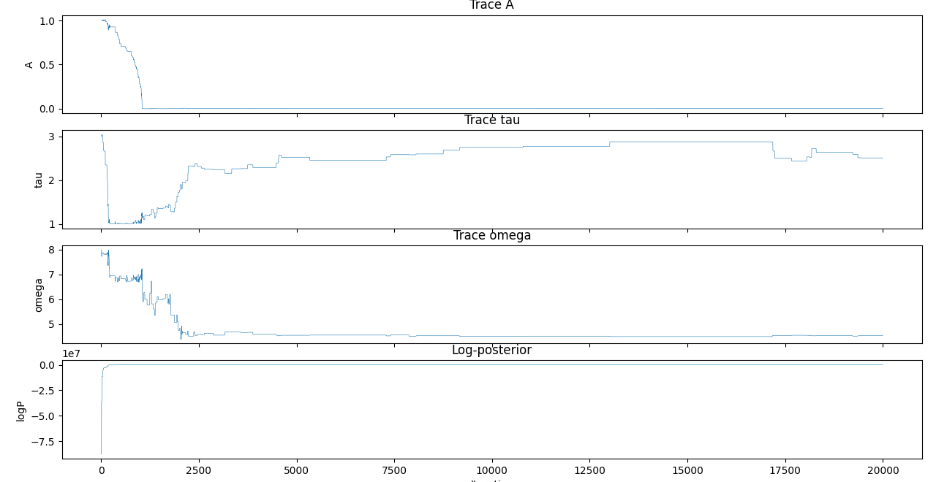

2. Posterior Histograms (posterior_histograms.png)
- Three histograms (one per parameter) showing kernel density estimate of post-burn-in samples.
- Red vertical lines mark MAP estimates (posterior mode).
- Width and shape reveal parameter uncertainty.
- Overlapping distributions indicate parameter correlations.
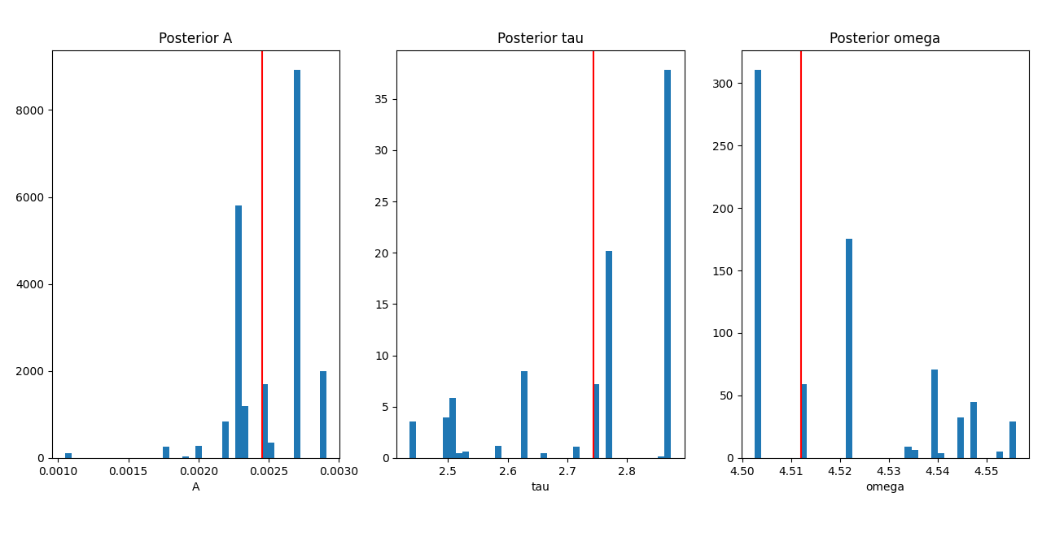

3. Data vs Model Fit & Residuals (fit_and_residuals.png)
- Top panel: Noisy observations (black dots), MAP model prediction (red line), and ±2σ uncertainty band.
- Bottom panel: Normalized residuals (data − model)/σ.
- Residuals within ±2σ band and without systematic trend indicate good model fit.
- Validates that the recovered parameters successfully explain the observed signal.

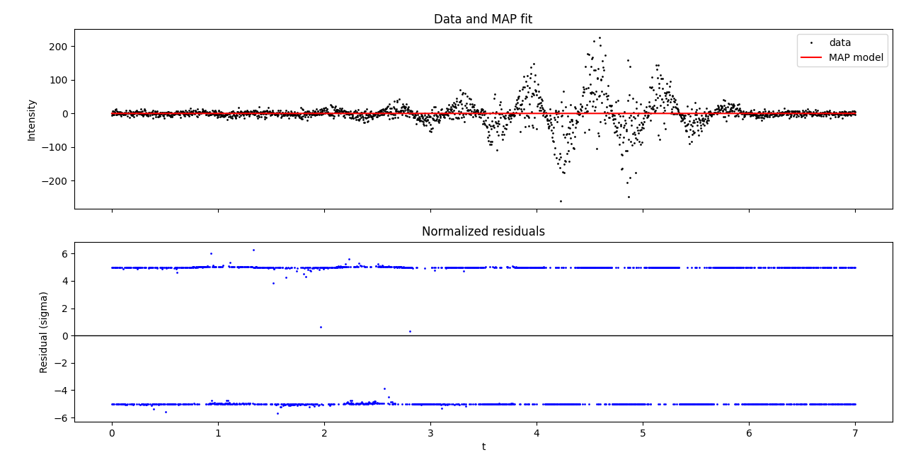

Software, Libraries, and Tools Used:

- Python 3.x – https://www.python.org.
- NumPy (numerical arrays, mathematical functions) – https://numpy.org.
- Matplotlib (publication-quality visualization) – https://matplotlib.org.
- Standard Library (random, math) – Built-in Python modules.

Declaration
We certify that this simulation, report, and source code are original works developed by the team for academic and educational purposes in fulfillment of the Solar Flare Pulse: Stochastic Signal Recovery competition. All external libraries and methodologies are properly cited, and the Bayesian inference framework follows established statistical practice in computational astrophysics.

